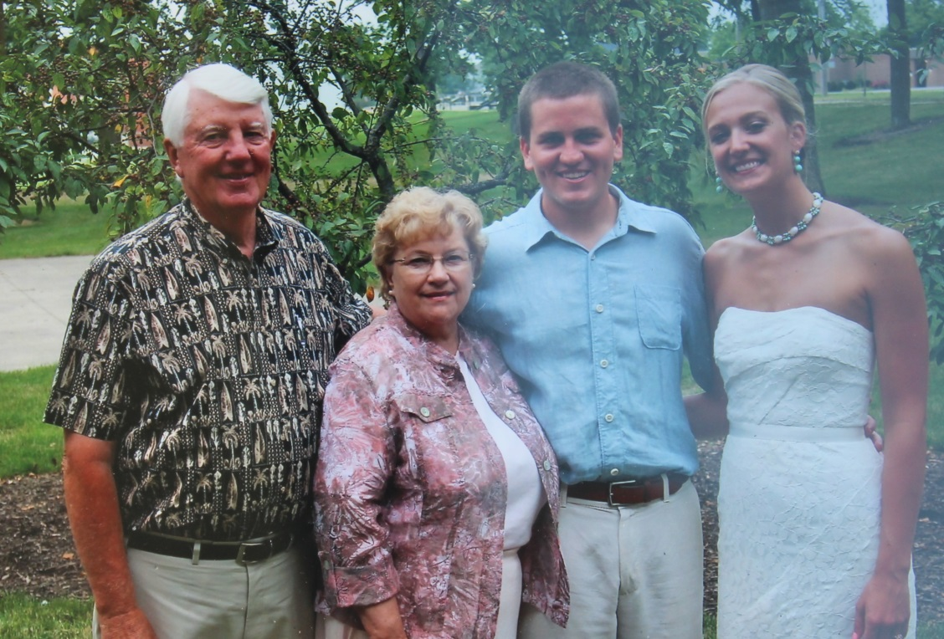

**David Wolfe List, Carolyn Huffer List, Joshua David List, Samantha Schumann – 2013**

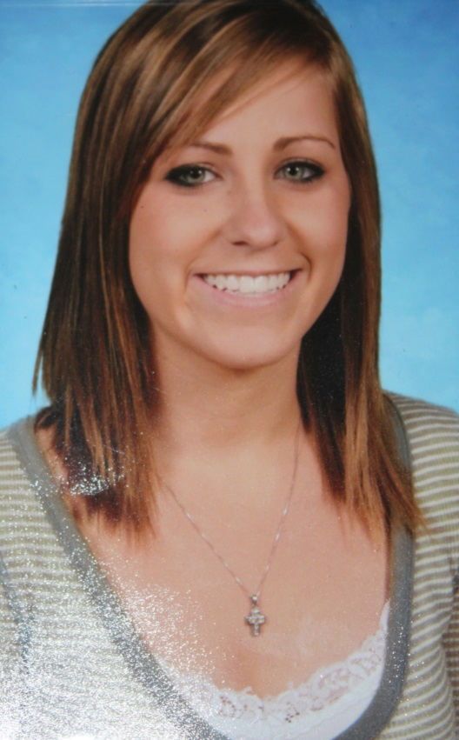

**Jessica Anne List - 2008**